The 31th Japan Agricultural Formulation
and Application Symposium
Organized by Pesticide Science Society of Japan, Japan Agricultural Formulation and Application Group
Support academic societies
Japan Society of Color Material
Japan Oil Chemists’ Society
The Chemical Society of Japan
The Japanese Society of Agricultural Machinery
The Society of Polymer Science, Japan
The Society of Powder Technology, Japan
The Weed Science Society of Japan

1. Date: September 29 – 30, 2011

2. Place
This year’s conference will be held at:
“Tsukuba International Congress Center, EPOCHAL TSUKUBA”
Address: 2-20-3, Takezono, Tsukuba, Ibaraki, 305-0032 Japan
Tel: +81-29（861）0001
Fax: +81-29（861）1209

http://www.epochal.or.jp/eng/index.html

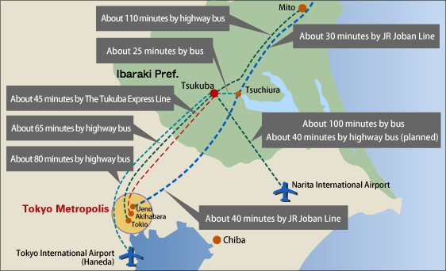
Position of Tsukuba City

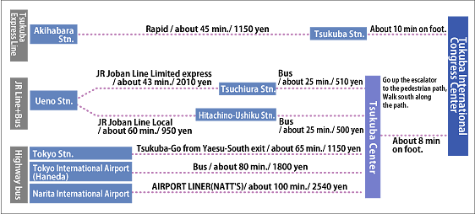
Access to Tsukuba City

Area Map
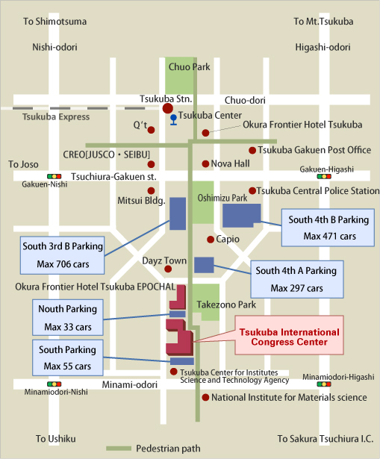

From Tsukuba Station:
Go up the escalator at Exit A3. Turn right at a ticket office, then, go up the front steps. Go straight approximately for 800m.
3. Program
September 29 (Thu) 13:00 – 17:30
1) Invited Lecture 1
"Action for Agrochemicals as Ibaraki Co-op (tentative title)"
Tomoko Yajima (Ibaraki Co-op)

2) Banquet 18:00-20:00

September 30 (Fri) 9:30 – 16:00
3) Invited Lecture 2
"The Present Situation and Future Prospects of Plant Protection in Ibaraki Prefecture (tentative title)"
Yasunori Tomita (Ibaraki Plant Protection Office)

4) Invited Lecture 3
"Carriers of Pesticide Formulations (tentative title)"
Kenichi Kimura (Neoraito Kosan Co., Ltd)

4. Registration
Please fill the attached registration form and send it by mail, fax or e-mail to the following address.

Kazuhiko Tane
Pesticide Formulation Group, Oppama Research Laboratory
Toho Chemical Industry Co, Ltd.
5-2931,Urago-Cho,Yokosuka-Shi,Kanagawa, 237-0062, Japan
TEL: +81-46-866-5736 FAX: +81-46-866-5731
E-mail: seizaisympo@toho-chem.co.jp

Deadline for registration: June 17, 2011.

Registration fee: on or before June 17, 2011
JP\16,000 (members of the Pesticide Science Society of Japan)
JP\17,000 (non-members)
after June 18, 2011
JP\20,000

Registration fee will include cost of the September 29th banquet, lunch on 30th and a booklet of abstracts, and should be paid upon arrival in Japanese currency. In addition, you can pay the registration fee with a credit card below the URL.

http://biz1.dynacom.jp/cgi-bin/pssj/member/card_general.cgi

5. Accommodations
Please make a reservation by yourself.

6. Call for papers

Those who are interested in poster presenting at the symposium should fill in the "Application for presentation" form and send it to the following address of the symposium secretary by June 17.
Poster presentations including 5 minutes oral presentation should be subjected on “Agricultural formulation and application”.

Dr. Katsushi Morimoto
Agricultural Chemicals Research Department, Chemical Research Laboratories
Nissan Chemical Industries, Ltd.
10-1, Tsuboinishi 2-chome, Funabashi-city, Chiba 274-8507, Japan
TEL: +81-47-465-1116 FAX: +81-47-467-5307
E-mail: 31seizaisympo@nissanchem.co.jp

Abstract format
Abstracts for poster presentation should be made according to the following guidelines and submitted to the above symposium organizer by July 1, 2011.

*Abstracts should be 1-2 pages in length
*80 English words/line, 32lines/page including title, authors and affiliation.
*A checkmark should be placed beside the presenter's name. (Example) ○Ogawa,・・
*Margin Right and left : 20mm
Upper: 20mm
Bottom: 25mm

Presentation Equipment Information
A poster board (100 x 210 cm) will be provided for each poster presentation. A table is also available upon request, at a separate rental charge (JP\30,000).
PC and overhead projectors are available to participants doing 5 min oral presentation. MS Power Point is the preferred format for PC presentations and your file of the presentation must be sent to following address by e-mail by August 26, 2011.

Dr. Katsushi Morimoto
Agricultural Chemicals Research Department, Chemical Research Laboratories
Nissan Chemical Industries, Ltd.
10-1, Tsuboinishi 2-chome, Funabashi-city, Chiba 274-8507, Japan
TEL: +81-47-465-1116 FAX: +81-47-467-5307
E-mail: 31seizaisympo@nissanchem.co.jp

Abstract Format

20 mm

□□□□□ Title 2 lines
4 lines □□□□□ Sub-title （Please start after 10 blanks）
□□□Authors（Affiliation） 2 lines
□□□ (Please start after 6 blanks）
Summary
20 mm 20 mm
80 English words／line×32 lines

32 lines

25 mm Size: A4 Paper
(210 x 297 mm)
Registration Form
The 31th Japan Agricultural Formulation and Application Symposium

NO. Name Affiliation and address including Tel & Fax numbers
１
２
３
４
５
６
７
８
９
１０
 | Total Participants | Total Registration Fee  \

Application for presentation
The 30th Japan Agricultural Formulation and Application Symposium

Presenter：

Affiliation and Address：

TEL： FAX：

Presentation Title ：

Presentation type
- Poster (panel only)
- Poster (panel and table)

Deadline: July 17, 2011

