**The 43rd Japan Agricultural Formulation**

**and Application Symposium**

Organized by Japan Agricultural Formulation and Application Group, Pesticide Science Society of Japan

**Support academic societies**

**Japan Society of Color Material**

**Japan Oil Chemists’ Society**

**The Chemical Society of Japan**

**The Japanese Society of Agricultural Machinery**

**The Society of Polymer Science, Japan**

**The Society of Powder Technology, Japan**

**The Weed Science Society of Japan**

**1. Date:** October 10 – 11, 2024

**2. Place**

This year’s conference will be held at:

“Tsukuba International Congress Center, EPOCHAL TSUKUBA”

Address: 2-20-3, Takezono, Tsukuba, Ibaraki, 305-0032 Japan

Tel: +81-29（861）0001

Fax: +81-29（861）1209

http://www.epochal.or.jp/eng/index.html

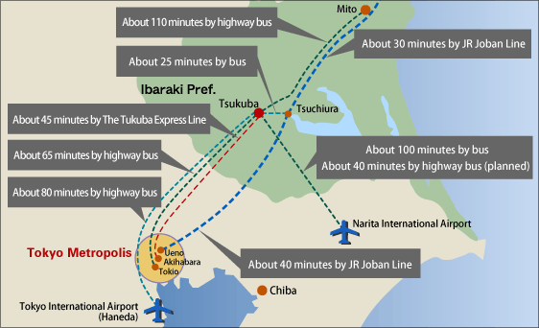**Position of Tsukuba City**

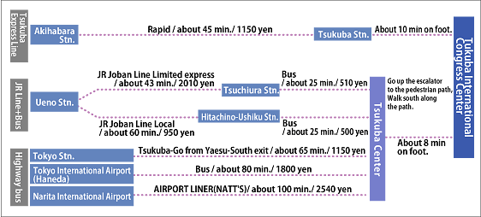**Access to Tsukuba City**

**Area Map**

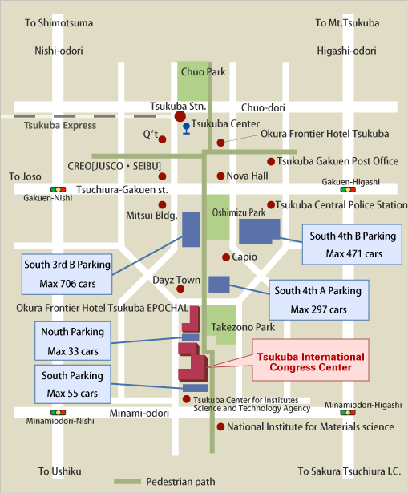

From Tsukuba Station:

Go up the escalator at Exit A3. Turn right at a ticket office, then, go up the front steps. Go straight approximately for 800m.

**3. Program**

**October 10 (Thu) 13:00 – 17:30**

**Banquet 18:00-20:00**

**October 11 (Fri) 9:00 – 16:00**

1) Invited Lecture 1

“Development of technology for using UAV to control fruit tree pests”

Dr. Hiroshi Shiotani（Institute of Fruit Tree and Tea Science, NARO）

2) Invited Lecture 2

「Current status and future prospects of pesticide application with UAVs in Taiwan」

Dr. Yang, Shang-wei (Agricultural Chemicals Research Institute (ACRI), Taiwan Ministry of Agriculture)

3) Invited Lecture 3

「Occurrence and control of difficult-to-control alien weeds in Japan」

Dr. Akira Koarai（Institute for Plant Protection, NARO）

4) Invited Lecture 4

「Towards Sustainable Agriculture: High-Function Pesticides with Reduced Environmental Impact via Continuous Synthesis and Micronization」

Prof. Shu Kobayashi（The University of Tokyo）

5) Invited Lecture 5

“Appropriate materials and preparation for emulsions: What would you do if you have no surfactant?”

Prof. Toshio Sakai（Shinshu University）

**4. Registration**

Please apply for registration at the website below and is scheduled to start in mid-May.

[https://seizaiseyouhou43.peatix.com](https://seizaiseyouhou43.peatix.com/)

Advance rate fees apply until July 31, 2024.

|  |  |  |
| --- | --- | --- |
|  | Early bird  By July 31, 2024 | Normal  August 1- October 11, 2024 |
| Members of  the Pesticide Science Society of Japan or the support societies | **\8,000** | **\14,000** |
| Non-members | **\12,000** | **\14,000** |
| Banquet | **¥7,000** | **¥7,000** |

Registration fee will include cost of lunch on 11th and a booklet of abstracts.

For inquiries regarding registration and payment, please contact below.

Takashi Sasaki

Pesticide Formulation Group,

Toho Chemical Industry Co, Ltd.

10, Kitasode, Sodegaura-Shi, Chiba, 299-0266, Japan

TEL: +81-438-62-3994 FAX: +81-438-62-3899

E-mail: seizaisympo43@toho-chem.co.jp

**5. Accommodations**

The secretariat does not organize hotel accommodations. Please make a hotel reservation by yourself.

**6. Call for papers**

Those who are interested in technical presentation at the symposium should fill in the "Application for presentation" form and send it to the following address of the symposium secretary by June 28.

“15 minutes oral presentation and poster presentation including 3 minutes oral presentation should be subjected on “Agricultural formulation and application”.

Junichi Kouchi

Agricultural Chemicals Research Department, Chemical Research Laboratories

Nissan Chemical Corporation

10-1, Tsuboinishi 2-chome, Funabashi-city, Chiba 274-8507, Japan

TEL: +81-47-465-1116 FAX: +81-47-465-5307

E-mail: seizaisympo43@nissanchem.co.jp

Abstract format

Abstract for oral and poster presentation should be made according to the following guidelines and submitted to the above symposium organizer by July 31, 2024.

*Abstracts should be 1-2 pages in length

*80 English words/line, 32lines/page including title, authors and affiliation.

*A checkmark should be placed beside the presenter's name. (Example) ○Ogawa,・・

*Margin Right and left : 20mm

Upper: 20mm

Bottom: 25mm

Presentation Equipment Information

A poster board (100 x 210 cm) will be provided for each poster presentation. A panel usage fee of 20,000 yen will be charged for the poster session.

PC and overhead projectors are available to participants doing oral presentation. MS Power Point is the preferred format for PC presentations and your file of the presentation must be sent to following address by e-mail by September 13 2024.

Junichi Kouchi

Agricultural Chemicals Research Department, Chemical Research Laboratories

Nissan Chemical Corporation

10-1, Tsuboinishi 2-chome, Funabashi-city, Chiba 274-8507, Japan

TEL: +81-47-465-1116 FAX: +81-47-465-5307

E-mail: seizaisympo43@nissanchem.co.jp

Abstract format

20 mm

□□□□□ Title 2 lines

4 lines □□□□□ Sub-title （Please start after 10 blanks）

□□□Authors（Affiliation） 2 lines

□□□ (Please start after 6 blanks）

Summary

20 mm 20 mm

80 English words／line×32 lines

32 lines

25 mm Size: A4 Paper

(210 x 297 mm)

**Application for presentation**

***The 43rd Japan Agricultural Formulation and Application Symposium***

Presenter：

Affiliation and Address：

TEL： FAX：

Presentation Title ：

Presentation type

* Oral
* Poster (panel only)
* Poster (panel and table (Max. load 30kg))
* Poster (panel and table (Max load 60kg))

**Deadline: June 28, 2024**